Job Description - DRAFT

Job Title: | PMO Project Administrator
Team: | Business and Tourism Programme
Classification: | Non-Manager
Reports to: | Senior PMO Analyst
Classification of Line Manager: | Manager
Number of Direct Reports: | 0

Job Purpose
Birmingham 2022 is a golden opportunity not just for the West Midlands but for the UK. With a third of the world’s population tuning in, this is a chance to show that post-EU Exit Britain is open for business, support economic recovery from COVID-19 and to provide a shop window for Britain’s economic engine.

London 2012 and previous Commonwealth Games demonstrate the potential to drive tourism, trade and investment alongside the sport and culture. Funding has been secured to deliver a major programme to attract visitors, investors and events to the West Midlands and the UK, and grow export opportunities. This will be delivered in partnership at regional and national level, with funding secured in the Spring 2020 Budget and match funding from the West Midlands Combined Authority (WMCA). The programme is currently being developed – so an exciting time to join and help shape what will be delivered.

A central programme team supports the programme delivery partners (West Midlands Growth Company (WMGC), Department for International Trade (DIT) and VisitBritain (VB)). Based in central Birmingham at the WMGC offices on Centenary Square, the team will delivery cross-cutting activity and ensure integration within the programme, with the Birmingham 2022 Organising Committee (OC) and with relevant regional / national initiatives.

The programme has a diverse range of markets (UK, Australia, Canada, India, Singapore and Malaysia) and audiences including Commonwealth leaders, investors, event organisers and leisure visitors. Alongside the core budget, the programme will be amplified working with sponsors, with IP being parts of their rights packages.

Role runs from January 2022 – October 2023.

Our people and our offices
West Midlands is an exciting, vibrant and diverse region and West Midlands Growth Company aims to reflect this in all that we do. Our objective is that our work, services and employment practices will promote a positive impression of the region, and we will take every step to minimise or eliminate outdated preconceptions and stereotypes.

West Midlands Growth Company whole-heartedly supports the principle of equal opportunities in employment and opposes all forms of unlawful or unfair discrimination on the grounds of colour, race, nationality, ethnic or national origin, sex, disability, age, religious belief, sexual orientation or marital status.

We believe that it is in the company's best interests and of all those who work in it to attract, retain and develop a diverse pool of talent. We therefore seek to ensure that the human resources, talents and skills available throughout the community are considered when employment opportunities arise. We believe it is essential to the company's success to enable employees of all backgrounds to reach their full potential by encouraging a working environment that is inclusive to all.

To this end and within the framework of the law we are committed, wherever practicable, to achieving and maintaining a workforce which broadly reflects the local community in which we operate.

This is a remote working opportunity until a date is agreed for the West Midlands Growth Company workforce to return to the usual place of work at The Colmore Building, Birmingham.

Our priority is to keep all our employees safe and well during this time. We will be working remotely for the foreseeable future, and we are doing everything we can to ensure all our employees can enjoy a comfortable remote working space.

Main responsibilities and key activities
• Support the Senior PMO Analyst and Programme Coordinator on the co-ordination of the programme assurance and governance requirements, ensuring that there is a smooth-running assurance process for the PMO
• Work closely with the Project Managers and Head of Projects and Programmes to ensure that all key actions, risks and issues are being managed or escalated
- Forge relationships with partners and funders of the programme to help support both WMGC and them to deliver
• Manage the programme meetings, write agendas and minutes, providing secretariat services as required, collating required information and follow up actions
- Manage the programme inbox and calendar
• Maintain and version control documentation
- Manage folder structures
• Support work across programme partners to ensure consistent reporting and requirements from the PMO
• Support the wider programme team in the coordination of deliverables, raising risks and issues as appropriate
- Support and suggest ideas for improvement and efficiencies

Dimensions
Programme team structure (DRAFT): this may evolve as the programme develops

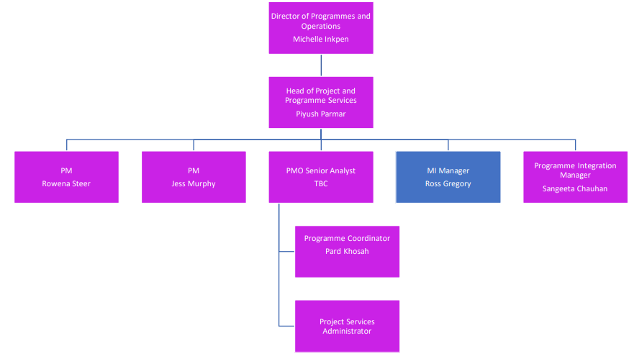

Key relationships:
- Programme Director
- Programme partners and wider stakeholders
- Project Managers
- Work stream leads
- Finance & Procurement
- Wider programme delivery team
- WMGC Extended Leadership Team (ELT)

Key Skills and Competency Requirements
Area | Essential | Desirable
Qualifications | - Post School qualification, such as A-Levels, NVQ. Must have English GCSE | - Post A-Level qualified or any additional vocational experience
Skills and attributes | - Excellent communication and ability to work with a number of people across the organisation  - Proactive approach to support delivery  - Able to work in a fast-paced environment and manage multiple assignments via a number of sources/people  - Self-motivated and deadline-driven  - Excellent attention to detail  - Ability to work unsupervised in programme delivery environment | - Had previous experience of having worked in a fast paced environment
Knowledge and experience | - Working in a multi-stakeholder / delivery partner environment  - Ability to understand key concepts around the project environment including governance and assurance processes.  - Ability to maintain programme documentation including collating reports and information requirements  - Experience of writing agendas, minutes, diary management and secretariat duties within a PMO environment | - Experience in a project management environment or events-based environment  - Experience within a similar role

Our values
Working together | We take pride in our approach to working together in a diverse, open and inclusive environment.
Creative thinker | We are creative and innovative in the work that we do, in our delivery and our outputs.
Trusted partners | We are a trusted partner – we work together with clients and stakeholders for the benefit of the region.
Proactive leader | We are proactive leaders continually striving for excellence, passionate about unlocking potential for the West Midlands.

Prepared by:
Name | Job title | Date
Piyush Parmar | Head of Projects and Programmes | December 2021

